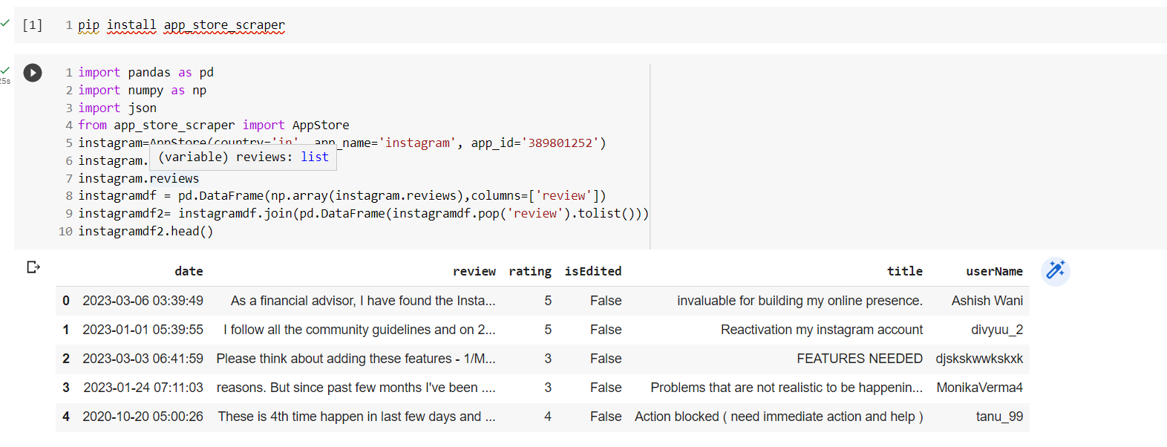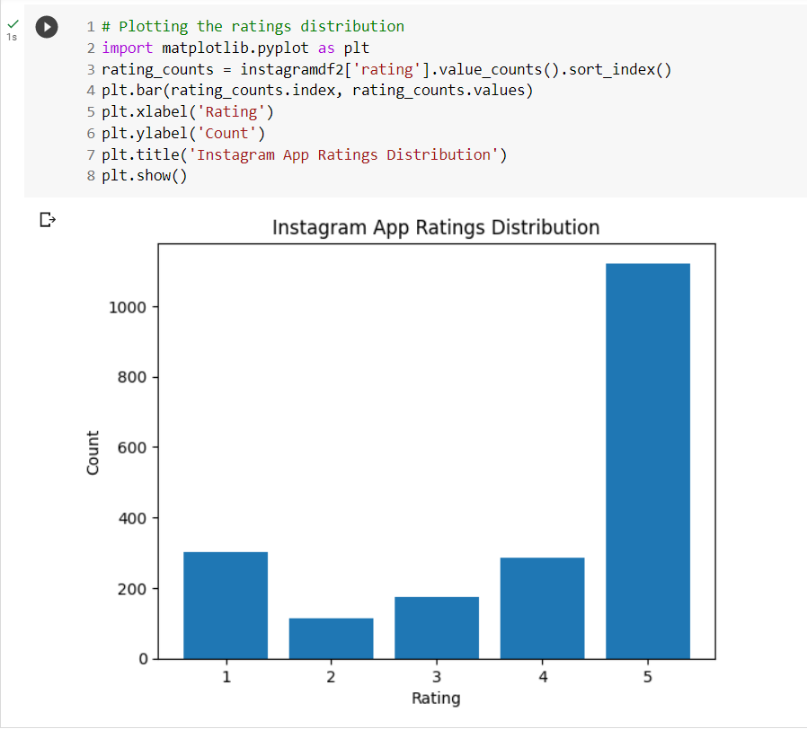

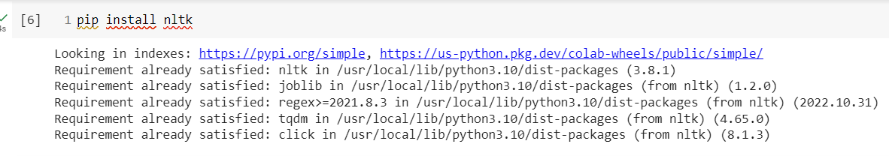

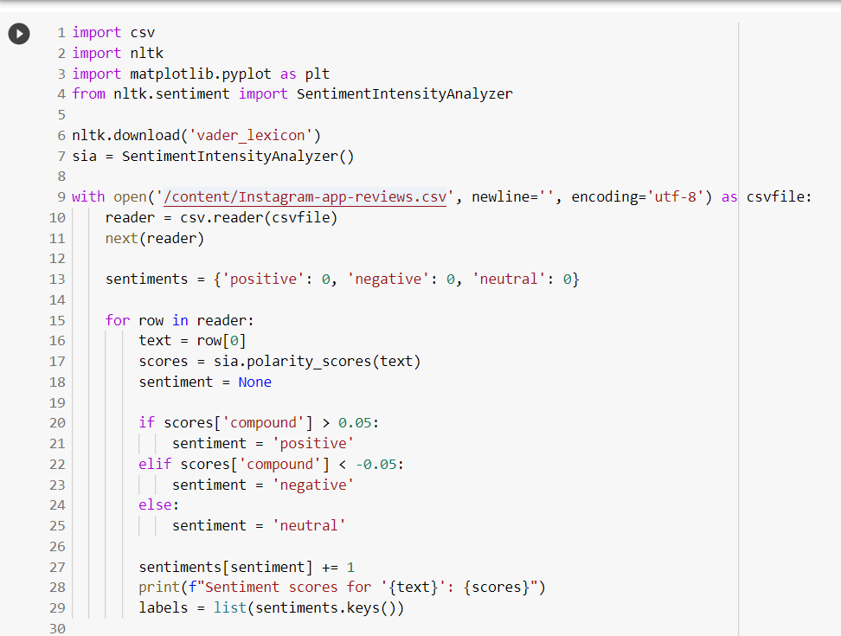

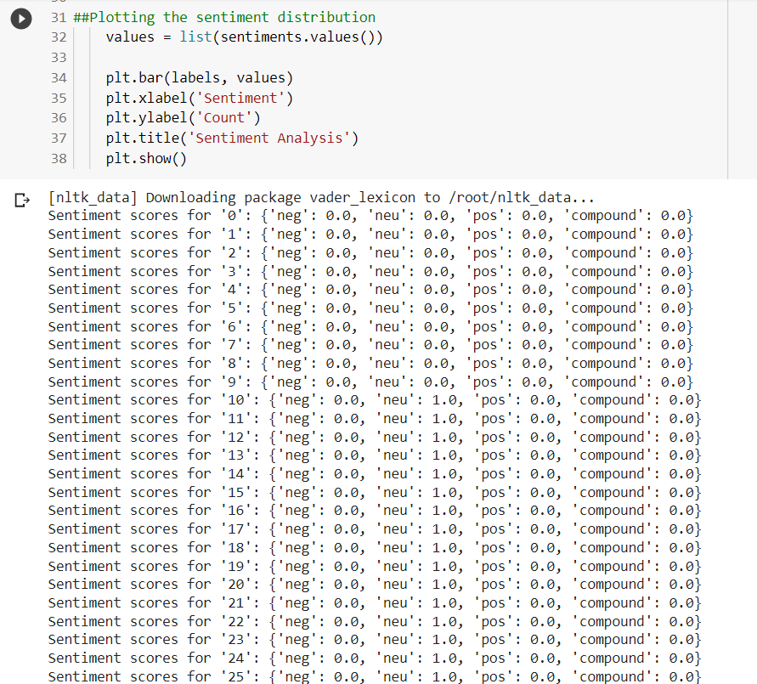

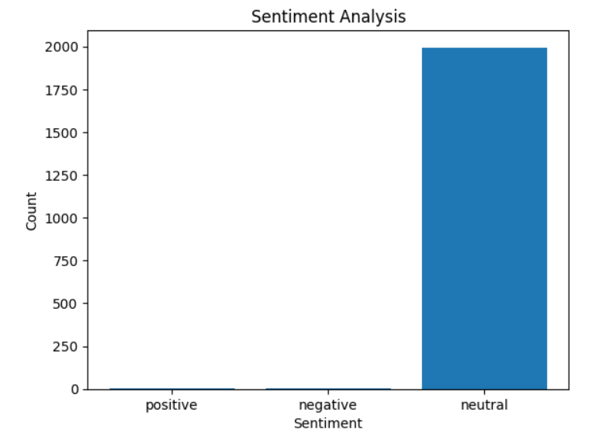

**CODE LINK**

**https://colab.research.google.com/drive/1anuurTmqYgYEKgYSCBjtIUBJ2fCr_10y#scrollTo=PgaSMV4ADLpN**